**Bug Report**

**Issue**: User is able to login to the application with incorrect set of Username and Password.

**Steps to reproduce:**

1. Go to the Login screen
2. Put Username as “problem_user”
3. Put password as “secret_sauce”
4. User lands on Home screen

**Expected:**An  Error message should appear with content : **Epic sadface: Username and password do not match any user in this service**

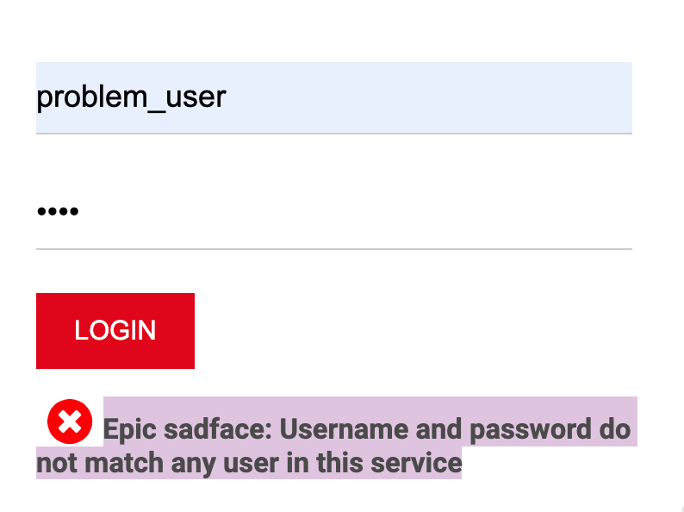

**Actual**: User is able to login with incorrect credentials

